Report 2

108062135 呂佳恩

1. Screenshots

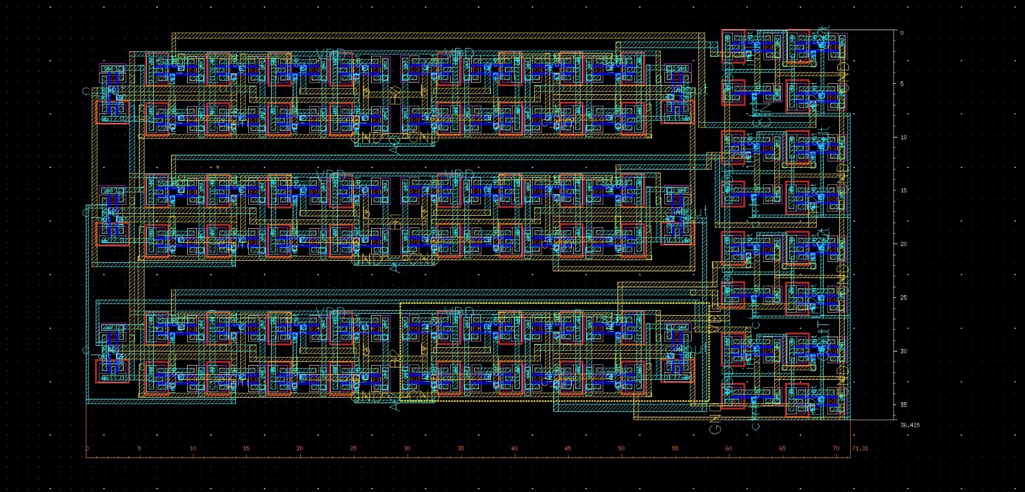Screenshot of ADDER3

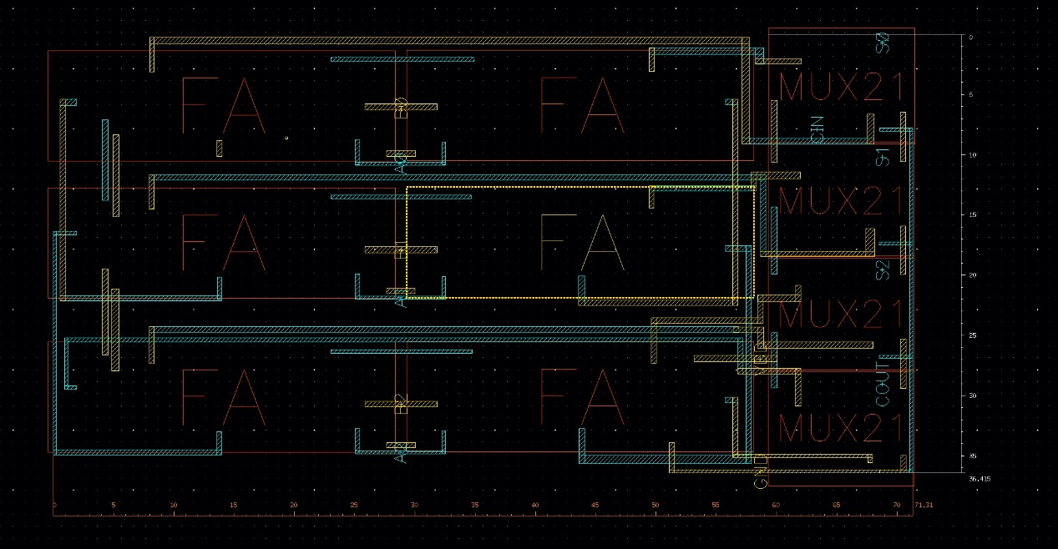

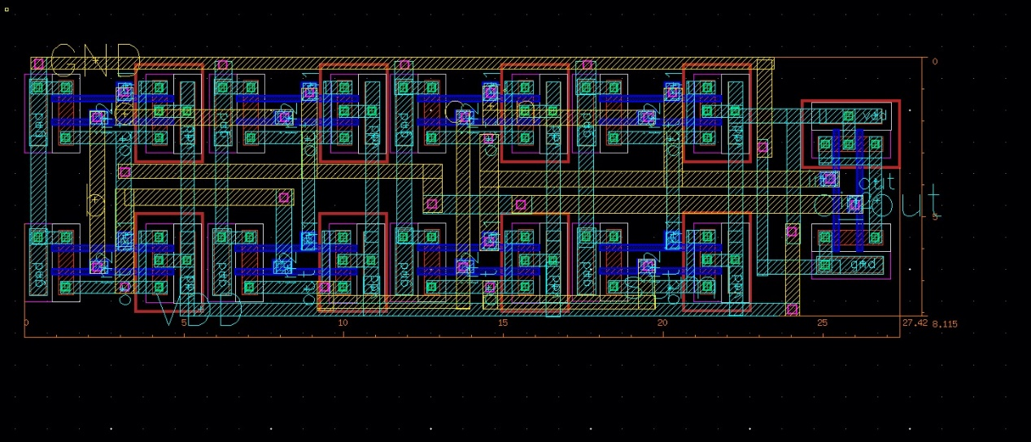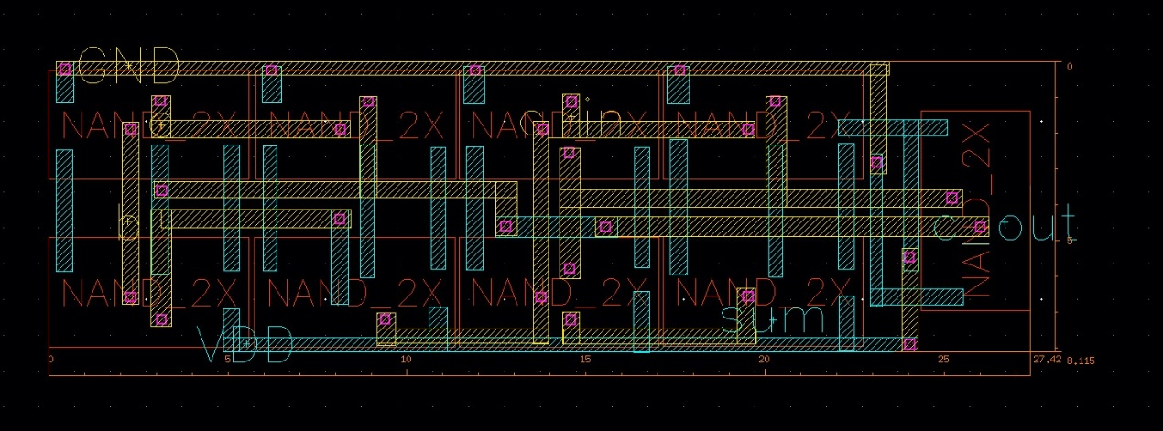Screenshot of FA

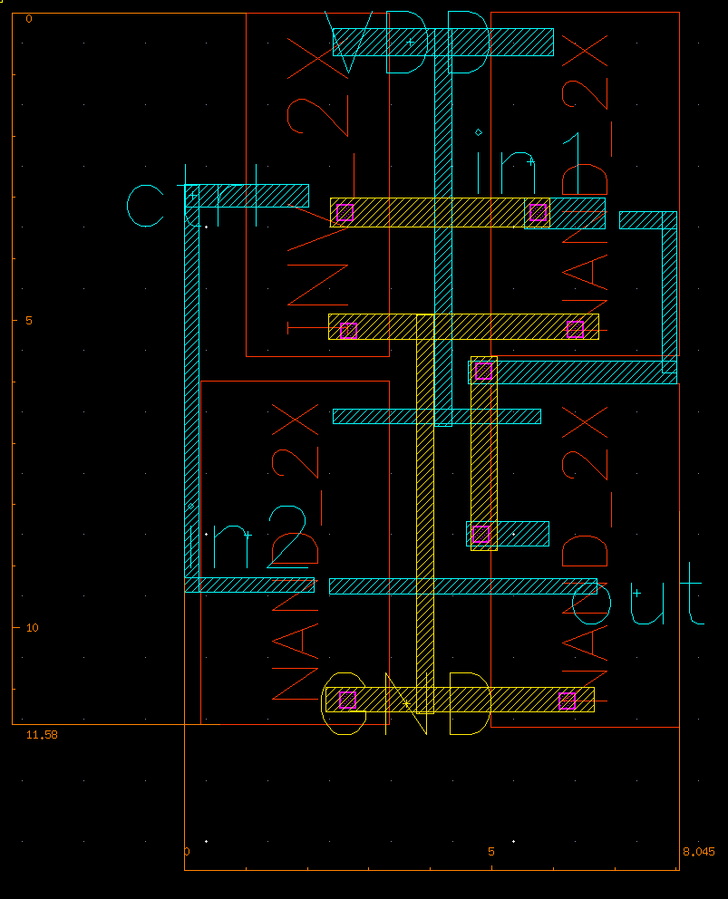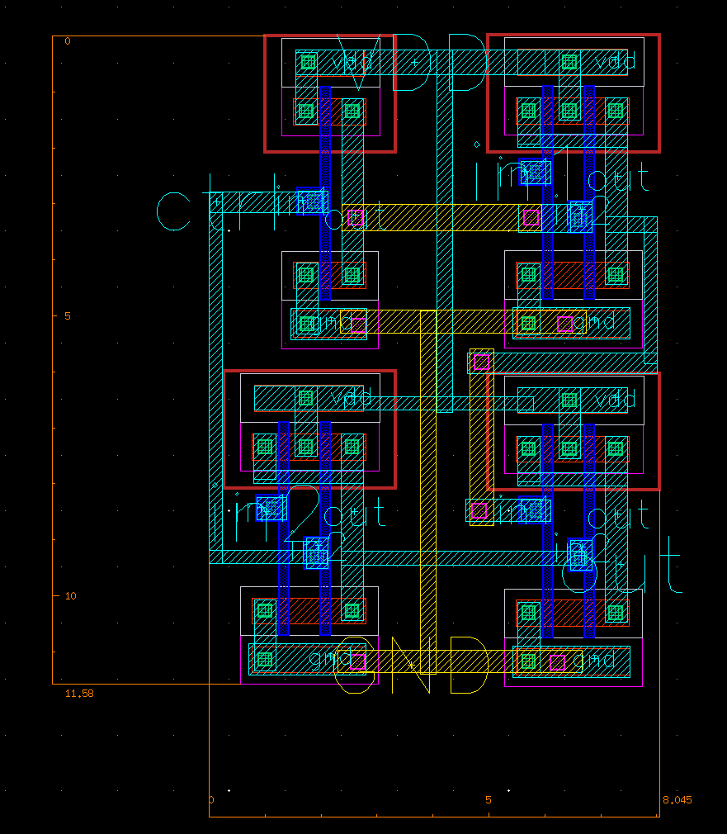Screenshot of MUX

Screenshot of DRC summary report

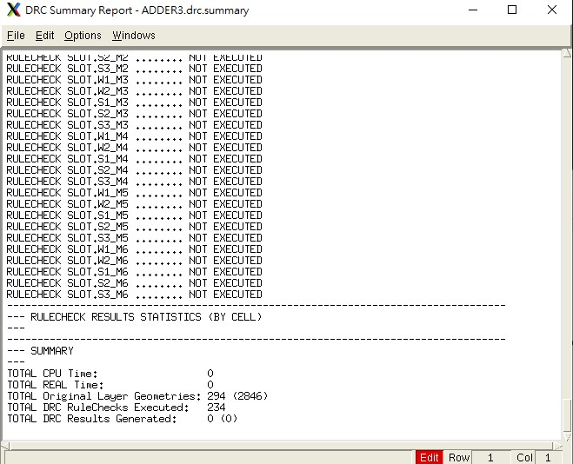

Screenshot of LVS report

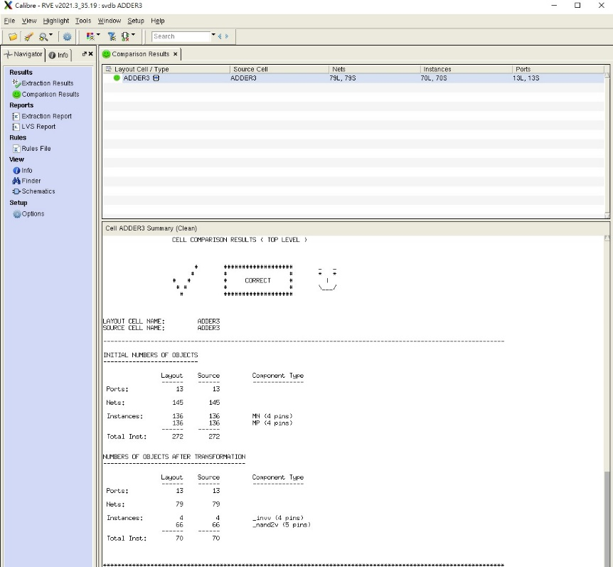

Screenshot of LVS schematic of Adder3.src.net

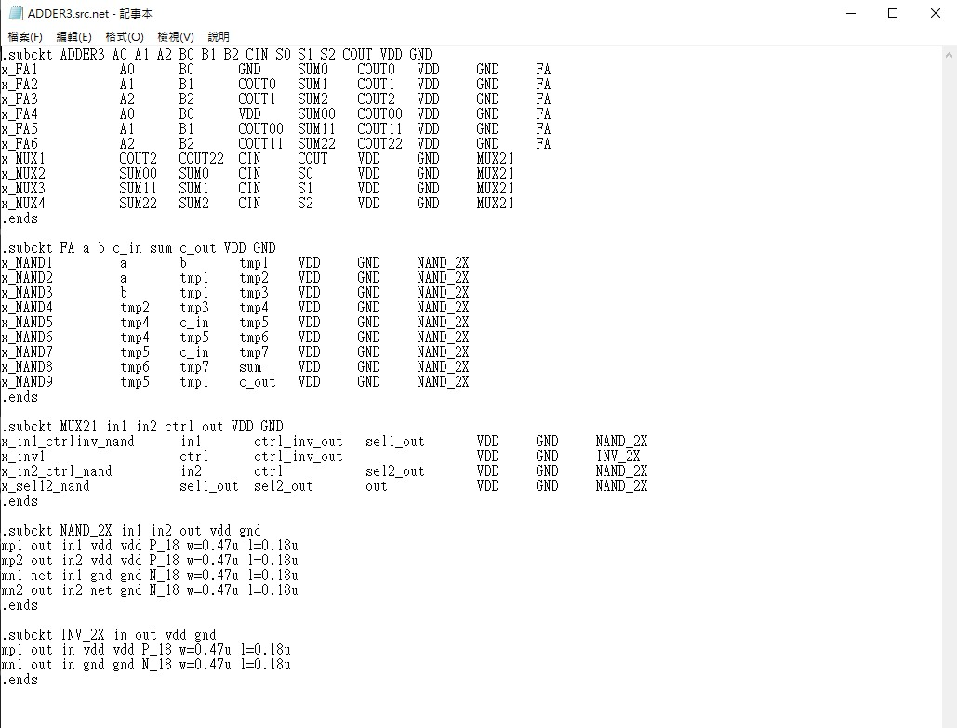

1. What else did I do to enhance my layout quality?

I started with the idea of making the design of FA and MUX easy to use in FA, so the output placement was crucial when I began the design. Also, the VDD and GND placement was place into consideration when the initial design was started.

Also, I sometimes flipped the design as it would benefit the routing of the total design.

1. What have you learned from this homework?

I have a deep understanding of how Virtuoso works, and during the process of doing the homework, I have a better understanding of all things that need to be considered when doing designs, it made me appreciate the work of others more.

1. What problems have you encountered in this homework?

The main problem I encountered is that I don’t know whether a placement would cause problems in the future or not. Also, small problems cascade into bigger ones as the layout scales. This made me have to go back to re-arrange the layouts that I first placed again and again, which was very time consuming.